Spearman rank correlation: USDJPY and EURGBP
Method 02 / daily log returns / Alpari D1 full available history

Study setup
Logical pair: USDJPY , EURGBP
Broker symbols: USDJPY_i , EURGBP_i
Snapshot: 2026-11-03_majors_alpari_D1
Timeframe: D1
Matched return window: 1999-01-06 to 2026-11-02 (UTC bar dates)
Matched return count n: 7181
Dropped unfinished last bar dated 2026-11-03 UTC after a tick-volume check against the prior complete day.
Complete matched rows (CSV): USDJPY-EURGBP_Spearman_D1.csv
Complete matched rows (HTML table): USDJPY-EURGBP_Spearman_D1_data.html

Method carried forward
Spearman rho is Pearson correlation on the ranks of matched daily log returns of close, ln(close_t / close_t-1), in the broker quote direction. Ties use average ranks. Quotes are not inverted. rho is symmetric under swap of the two symbols. rho = 0 means no consistent rank-order link in this sample; it does not mean no link of any kind. The score is not a cause, not a lead, and not a trading signal. Daily rows are not independent draws, so the two-sided p-value and approximate Fisher interval are reported and treated as secondary to rho. Same-sample Pearson r is shown only as a side check; a large rho minus r gap can flag outliers or a non-straight link.

Results
Spearman rho: -0.109100
Two-sided p-value: 1.83838e-20
Approximate 95% Fisher interval: [-0.131897, -0.086188]
Same-sample Pearson r: -0.127992
rho minus r: 0.018892

Conclusion
Over 7181 matched daily log-return rows for USDJPY and EURGBP (broker quote directions unchanged), Spearman rho is -0.1091 (negative, weak rank-order association in this sample). Approximate 95% Fisher interval: [-0.1319, -0.0862]. Same-sample Pearson r is -0.1280 (rho minus r = 0.0189). Two-sided p under the usual independent-ranks model is 1.838e-20; that model does not match linked daily FX returns, so treat p as secondary. This does not establish cause, lead-lag, or a lasting trading rule.

Charts
Daily closes

Daily log returns
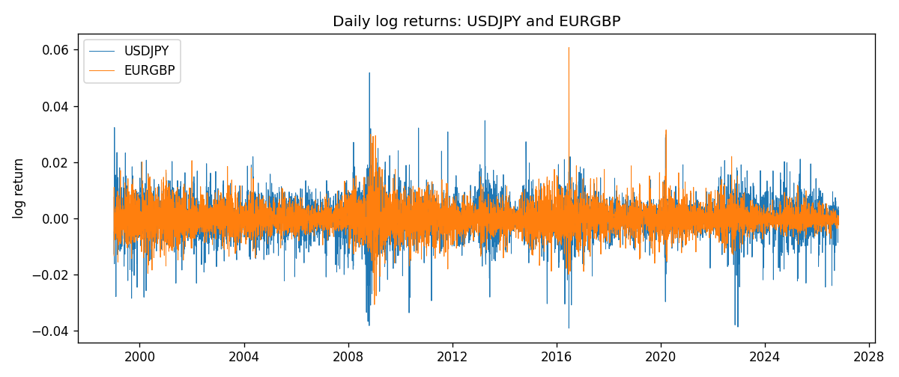
Log-return scatter
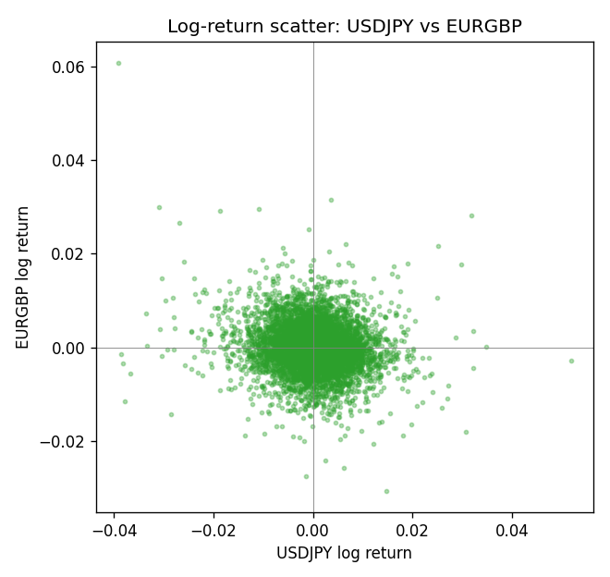
Rank-rank scatter
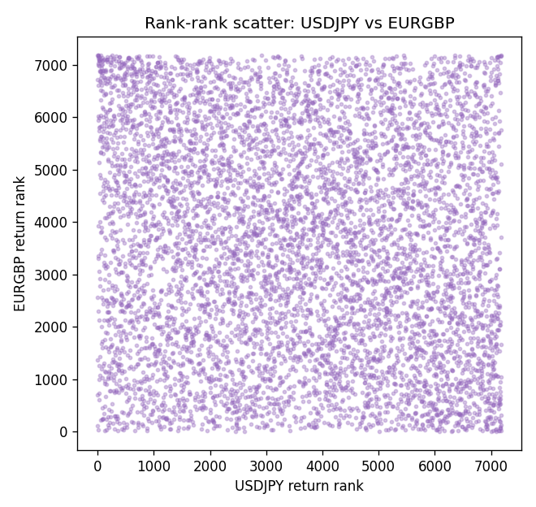

Data report
Every matched row that entered Spearman rho is stored in the sibling CSV named USDJPY-EURGBP_Spearman_D1.csv. That file is the complete data archive for redrawing charts. Embedding all rows as a Word table is impractical at this length; the Word file holds the column list, column summaries, and the first and last 15 matched rows.
Columns: time, USDJPY_open, EURGBP_open, USDJPY_high, EURGBP_high, USDJPY_low, EURGBP_low, USDJPY_close, EURGBP_close, USDJPY_tick_volume, EURGBP_tick_volume, USDJPY_spread, EURGBP_spread, USDJPY_real_volume, EURGBP_real_volume, USDJPY_log_return, EURGBP_log_return
Column summaries (matched calculation rows)
column | count | mean | std | min | 25% | 50% | 75% | max
USDJPY_open | 7181 | 113.80773 | 19.228846 | 75.693 | 104.38 | 110.98 | 120.71 | 163.824
EURGBP_open | 7181 | 0.78701429 | 0.09663819 | 0.5734 | 0.6877 | 0.83392 | 0.86523 | 0.9769
USDJPY_high | 7181 | 114.30513 | 19.290536 | 76.001 | 104.865 | 111.439 | 121.27 | 163.978
EURGBP_high | 7181 | 0.79009197 | 0.09701345 | 0.5789 | 0.6897 | 0.83701 | 0.8681 | 0.9799
USDJPY_low | 7181 | 113.28458 | 19.156841 | 75.402 | 103.87 | 110.53 | 120.172 | 163.628
EURGBP_low | 7181 | 0.78431381 | 0.09645598 | 0.5682 | 0.6857 | 0.83166 | 0.86287 | 0.9661
USDJPY_close | 7181 | 113.82069 | 19.244339 | 75.811 | 104.38 | 111.015 | 120.695 | 163.851
EURGBP_close | 7181 | 0.78705735 | 0.09663932 | 0.5735 | 0.6878 | 0.83401 | 0.86539 | 0.977
USDJPY_tick_volume | 7181 | 106398.86 | 179473.16 | 149 | 9958 | 53207 | 92916 | 1803508
EURGBP_tick_volume | 7181 | 87156.048 | 145513.65 | 154 | 6593 | 44384 | 81451 | 1424684
USDJPY_spread | 7181 | 20.250104 | 17.60648 | 0 | 6 | 11 | 30 | 50
EURGBP_spread | 7181 | 21.316669 | 19.115948 | 0 | 4 | 13 | 40 | 50
USDJPY_real_volume | 7181 | 3.4800425e+10 | 1.6097887e+11 | 0 | 0 | 0 | 0 | 3.8834203e+12
EURGBP_real_volume | 7181 | 2.788005e+10 | 1.3523257e+11 | 0 | 0 | 0 | 0 | 3.5726265e+12
USDJPY_log_return | 7181 | 4.847e-05 | 0.00620794 | -0.03908203 | -0.00320533 | 0.00011473 | 0.00340924 | 0.05184024
EURGBP_log_return | 7181 | 2.133e-05 | 0.00487349 | -0.03067367 | -0.00262366 | -0.00010035 | 0.00255918 | 0.06075387
First 15 matched rows (selected columns)
time | USDJPY_close | EURGBP_close | USDJPY_log_return | EURGBP_log_return | USDJPY_tick_volume | EURGBP_tick_volume
1999-01-06 | 112.77 | 0.7019 | 0.0075660159 | -0.013303338 | 6225 | 2635
1999-01-07 | 111.33 | 0.7097 | -0.012851583 | 0.011051402 | 6671 | 2464
1999-01-08 | 110.8 | 0.7062 | -0.0047719894 | -0.004943862 | 10700 | 3132
1999-01-11 | 109.02 | 0.7053 | -0.016195423 | -0.0012752393 | 9168 | 2418
1999-01-12 | 112.6 | 0.7077 | 0.032310364 | 0.0033970309 | 10131 | 2670
1999-01-13 | 113.52 | 0.708 | 0.0081373171 | 0.00042381861 | 7265 | 2612
1999-01-14 | 113.52 | 0.7066 | 0 | -0.0019793588 | 6335 | 2560
1999-01-15 | 114.15 | 0.7012 | 0.0055343401 | -0.0076715819 | 5479 | 3031
1999-01-18 | 114.16 | 0.7017 | 8.7600193e-05 | 0.00071280921 | 5482 | 2461
1999-01-19 | 113.52 | 0.7007 | -0.0056219403 | -0.0014261269 | 5702 | 2606
1999-01-20 | 112.91 | 0.7021 | -0.0053879917 | 0.0019960086 | 5919 | 2341
1999-01-21 | 113.87 | 0.7016 | 0.0084664056 | -0.00071240297 | 6251 | 2450
1999-01-22 | 114.56 | 0.7004 | 0.0060412564 | -0.0017118406 | 5453 | 2600
1999-01-25 | 113.72 | 0.6966 | -0.0073594164 | -0.0054402425 | 4696 | 2304
1999-01-26 | 113.86 | 0.6962 | 0.0012303367 | -0.00057438255 | 5805 | 3025
Last 15 matched rows (selected columns)
time | USDJPY_close | EURGBP_close | USDJPY_log_return | EURGBP_log_return | USDJPY_tick_volume | EURGBP_tick_volume
2026-10-13 | 158.305 | 0.84458 | -0.0018932826 | 0.00020130374 | 81731 | 30915
2026-10-14 | 158.317 | 0.84553 | 7.5800166e-05 | 0.0011241873 | 95596 | 39105
2026-10-15 | 158.024 | 0.84479 | -0.0018524319 | -0.00087557391 | 115120 | 45290
2026-10-16 | 157.964 | 0.84307 | -0.00037976126 | -0.0020380844 | 86475 | 39309
2026-10-19 | 158.517 | 0.84259 | 0.0034946841 | -0.00056950988 | 70872 | 38133
2026-10-20 | 158.16 | 0.83957 | -0.0022546642 | -0.0035906254 | 82689 | 42542
2026-10-21 | 158.108 | 0.83839 | -0.00032883504 | -0.00140647 | 67431 | 35843
2026-10-22 | 156.755 | 0.83682 | -0.0085942669 | -0.0018743924 | 100312 | 44479
2026-10-23 | 156.81 | 0.83751 | 0.00035080446 | 0.00082421033 | 103374 | 37399
2026-10-26 | 157.458 | 0.83762 | 0.0041238746 | 0.00013133309 | 87120 | 38735
2026-10-27 | 157.894 | 0.83595 | 0.0027651658 | -0.0019957343 | 72962 | 36303
2026-10-28 | 157.743 | 0.83651 | -0.00095679538 | 0.00066967224 | 72076 | 36532
2026-10-29 | 157.683 | 0.83553 | -0.00038043789 | -0.0011722209 | 88229 | 49261
2026-10-30 | 157.516 | 0.83351 | -0.0010596481 | -0.0024205543 | 106706 | 44060
2026-11-02 | 157.933 | 0.83426 | 0.0026438521 | 0.00089940465 | 80702 | 43437

